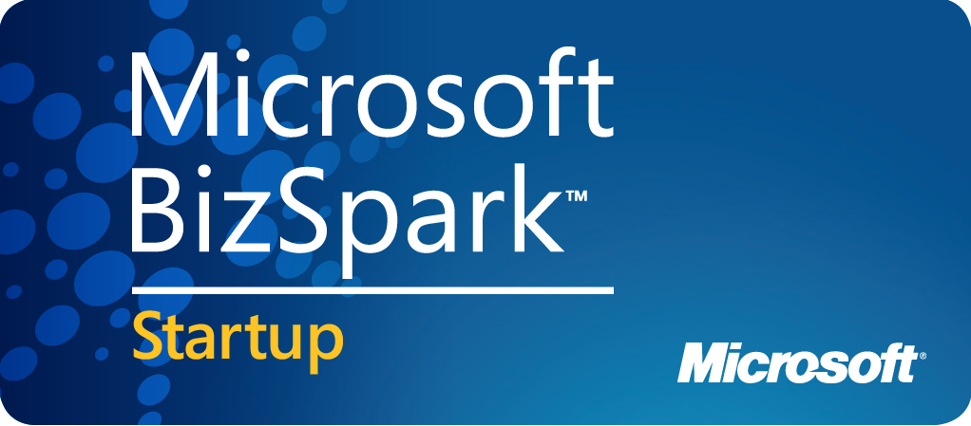

- Business Viability
  - Company Name: AgileApt Solutions P Limited
  - Company URL: www.agileapt.com
  - About the company : We are a software tehnology company having development center in Noida, Currently involved in developing software product (Sourcing Portal) which we intend to host on AZURE and offer as SAAS to our new customers.
  - Year of Inception : 17th July 2014
  - Copy of Incorporation Certificate (Mandatory) : Attached
  - Location (Street, City and State):
    - Registered Office: A-107-V, Green Glades, Golf Link-2, Greater Noida-Uttar Pradesh- 201010
    - Development Center: H-23, Sector 63, Noida, Uttar Pradesh - 201301
  - Company Stage (Initial/Yet to Incorporate/Startup/Developing/Matured) : Startup
  - No. of Employees: 4

- Team:
    - Founder Name’s with their education and experience background:
Name : Sunil Pandey
Education : PGDBM-Operations, MCA and BSC-Computer Science
Certification : PMP®, PMI-ACP®, CSM®, Six Sigma Green Belt
Background : Sunil is having 18+ years of experience in leading and managing product, mobile, web application development teams and communicating with various customers/key stakeholders and suggesting/ providing them best-fit technology solutions. Before starting this venture he was working with Moserbaer India Ltd as AGM- IT where he was leading web/mobile application development teams. His dream is to own a product having international level recognition.
Name : Mansi Pandey
Education : PGDBM-IT, MSC-IT
Certification : CSM®, PGDCA
Background : Mansi is having 13+ years of experience in writing codes, leading and managing, application development teams and communicating with various customers to ensure project success. She has extensiive expereince on microsoft technologies and Mcrosoft Dynamics CRM, Her dream is to lead a team working & maintaining a great product.
    - Number of Engineers: 4
- Product or Technology
    - Please describe your technology solution/s and the circumstances that led to its development:
Product Overview:

Our sourcing portal covers all the requirements of procurement - from the initial enquiry through RFQ (RFI/RFQ/RFP) and auctions, to detailed Cost Breakdowns and workflow approvals to optimize your award decision. The product is getting implemented at one of the fastest growing company in India.

The expension of this product would be a Supplier & Enterprise collaboration Portal where suppliers can register themselves and get connected to our existing enterprise customers and vice versa.

Circumtances that led to its development:

While working with Moserbaer, I selected developing reverse auction portal for Air & Sea shipments as part of my six sigma green belt project. The project was highly successful and during first year of implementation resulted into INR 1.8 Cr savings.

I left the organization and started my own business. In the meantime one of the guy who was in logistics team and using our application extensively left organization and joined Micromax.

He contacted us and enquired if we can provide more extensive product catering to Micromax requirements. We bagged the opportunity and this is how we started our product development.

    - Product Type (Hardware, Software (includes websites)):
      - Software Product
      - To be launched as SAAS platform
    - Please describe its target market and customer benefits:
      - The target market is SME’s who can’t afford big solutions like ARIBA and other costly sourcing portals.
      - Subscription modal will help them to use a tested product at much less cost while having access to features generally not available with small applications.
    - Please describe the platform it is built on and why you chose that platform?
Platform:

- HTML5
- CSS3
- jQuery, BootStrap & other js libraries
- Web Api’s (Written in c#)
- SQL Server 2008 R2

Reason of selecting these technologies
- Responsive Interface
- Background in .net based development
- Good command over WEB API’s
- Excellent understanding of Microsoft SQL Server

    - No of employees working on the product: 4
    - Are you building any apps on Windows Phone/Windows 8? If yes, please share the below information: No
            - How many phone/Win 8 (PC and tablet) application have you successfully developed?
            - How many of these phone/win8 applications have been published to an app store?
            - How many download of these applications?
            - No. of Consumer Apps vs. Enterprise Apps

    - Are you developing/hosting your Applications on Windows Azure? We will host it on Windows Azure once successfully implemented at Micromax.
- Legal
    - Is there any dispute going on with any of Microsoft subsidiaries? If yes, provide information. NO

